Search Customer



The Search Customer feature is located in the center of the Toolbar.  It allows you to use the NetView Insight Search to locate specific customers and view their NetView Insight pages (see “**NetView Insight**” for more information).

**Using Search Customer:** Click in the field.  Type in either the customer’s name, partial name, or customer number.  A new window will open showing the NetView Insight Search results:

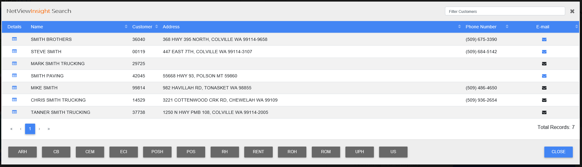

**To select an entry**, click on the row containing the desired customer’s information.  The row will be highlighted in green and a green check mark will appear to the left.  See “**Application Shortcuts Toolbar**” for the features you can access through selecting an entry. To de-select an entry, click on the row a second time, or click a different entry to select it instead.

**NOTE:** If you cannot find the entry you are looking for,you will need to either adjust your search criteria or use the **Search Features** tonarrow down your results (see “Search Features” for more information).